**• Product description**

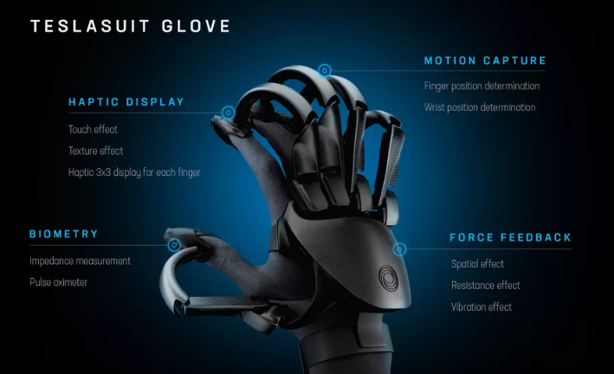

**Figure 1: example figure of VR gloves [1]**

This product which named Soulhand is a mechanical glove which combined multiple sensors in order to improve the experience of virtual reality.

VR technologies have been developed rapidly for these years, these technologies can provide various simulation software and functions for different areas, such as Medicine, engineering, games, etc.

Combining our product with VR technology or other Training simulators would bring a new use experience for consumers. Soulhand offers users a better way to control. Users don’t need to memorize button layout, and also don’t need to keep hold of a heavy controller that makes hands ache. Just slip Soulhand on, they could enjoy smooth control from every finger. Direct the control via the touch, proximity, pressure and gesture of fingers. No hold-ups. Just fantastic, intuitive, control.

**• Product Functionalities**

Soulhand VR Glove is created for capturing full hand and finger action in virtual reality. Users can now have both hands in the experience thanks to the full sensor technology. Soulhand VR Glove provides a lightning-fast response, pinpoint accuracy and plug-and-play convenience for transporting hands into the virtual environment.

1. Full hand and finger movement tracking for two-hand or single-hand modes supported. Plug-and-play with extremely quick and easy calibration.
2. Semiconductors can change the temperature of gloves and programmable vibration rumbler on each wrist provides haptic feedback for enhanced effects during VR experiences.
3. High performance 9-DOF IMU sensors with a gyroscope, accelerometer, and magnetometer for precise hand orientation. Mechanical damping structure could make people feel the softness of the object.
4. Dynamic simulation of water touch with the water content from 0 to 90% and an error range up to 1% by using a sensible nebulizer and electrical algorithm.
5. High accuracy and low <5 ms latency for seamless immersion into virtual reality.
6. High compatibility, Soulhand can work with HTC Vive, Oculus, Sony PlayStation, Samsung Gear, and other simulator supporting 4/5g wireless transmission.

* **Problems the product is solving**

Current gesture recognition sensors are not accurate or convenient enough, and most of them could not provide a tactile experience for users, such as leap motion [2], The SOULHAND improved accuracy of current gesture recognition and provided rich hand feelings for users.

1. The Soulhand has a higher accuracy

2. The Soulhand provides a tactile experience, users can experience the virtual world more realistically.

3. Greatly improved sensory experience

4. Greatly expanded the available functions of VR. For example, various simulation software that requires meticulous hand operation, Surgical Simulation, Aircraft driving simulation, etc.

* **Development plan**

**References**

[2] “leap motion”[online] access at: <https://www.ultraleap.com/tracking/> [14/04/2020]

[1]”VR gloves” [online] access at: <https://www.theverge.com/2019/12/26/21037855/teslasuit-glove-vr-haptic-feedback-glove-announce-pricing-release-date-ces-2020> [14/04/2020]